Chapter 11, Problem 62.

For the circuit in Fig. 11.81, find V_{s}.

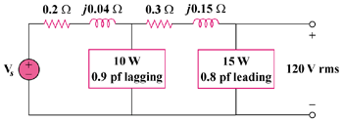

Figure 11.81
For Prob. 11.62.

